APPROVAL SHEET

This capstone project proposal entitled TITLE IN UPPER CASE prepared and submitted by CLEVERT ANDERSON BANASAN, JOSHUA JONES S. CALIXTO, DELSON F. FOCAD in partial fulfillment of the requirements for the degree BACHELOR OF SCIENCE IN INFORMATION TECHNOLOGY, has been examined and is recommended for acceptance and approval for oral examination

MELINDA A. BENINSIG, Degree
Adviser

CAPSTONE PROJECT COMMITTEE

Aldith Faith P. Mirador, Degree
Member

Efraim Jededia Z. Pangan, Degree
Member

DON HARL MALABANAN, Degree
Chairperson

TABLE OF CONTENTS
Page
TITLE PAGE . . . . . . . . . . . . . . . . . . . . . . 1
APPROVAL SHEET . . . . . . . . . . . . . . . . . . . . 2
TABLE OF CONTENTS . . . . . . . . . . . . . . . . . . 3 CHAPTER
1 INTRODUCTION
Rationale . . . . . . . . . . . . . . . . . 4
Project Objectives . . . . . . . . . . . . . 7
Proposed Solutions . . . . . . . . . . . . . 8
2 DESIGN THINKING
Empathize . . . . . . . . . . . . . . . . . 12
Define . . . . . . . . . . . . . . . . . . . 13
Ideate . . . . . . . . . . . . . . . . . . . 14
Prototype . . . . . . . . . . . . . . . . . 16
Test . . . . . . . . . . . . . . . . . . . . xx
REFERENCES . . . . . . . . . . . . . . . . . . . . . xx
APPENDICES
A Title . . . . . . . . . . . . . .. . . . . . xx
B Title . . . . . . . . . . . . .. . . . . . . xx
C Title . . . . . . . . . . . . . .. . . . . . xx

Chapter 1
INTRODUCTION
Rationale
The management of athlete profiles is a critical, yet often inefficiently executed, function within collegiate and amateur sports organizations. The prevailing status quo in many institutions, including our partner organization, relies heavily on manual data handling using spreadsheet software like Microsoft Excel and Google Sheets. In this environment, administrative staff bear the immense burden of acting as human databases—manually inputting, updating, and reconciling vast amounts of athlete information from disparate sources. This method, while seemingly low-cost, creates a fragile ecosystem prone to errors, inefficiencies, and data silos that ultimately hinder the organization's ability to effectively support its athletes (Ogunlere et al., 2020). The digital transformation sweeping across various sectors has exposed this manual paradigm as a significant bottleneck to operational excellence and strategic growth in sports administration.
The core problems inherent in the status quo are multifaceted. Firstly, data fragmentation is a fundamental issue. Critical athlete information—spanning personal details, academic records, performance metrics, and financial data—is typically scattered across multiple, unconnected spreadsheets. This absence of a single source of truth complicates information retrieval and forces staff to perform tedious manual cross-referencing, a process that is both time-consuming and vulnerable to oversight (Johnson & Lee, 2021). Secondly, this approach is characterized by profound operational inefficiency. Administrative personnel spend a disproportionate amount of their workday on repetitive data entry tasks rather than on higher-value analytical or supportive functions. Research in public administration has shown that such manual processes can consume over half of an employee's productive capacity, representing a significant drain on institutional resources (Smith & Chen, 2022). This inefficiency directly impedes the organization's agility and responsiveness.
Furthermore, manual, spreadsheet-based systems exhibit a high susceptibility to human error, which critically compromises data integrity. Simple typographical errors, incorrect cell references, or accidental data deletion can have cascading effects, leading to inaccurate reports and misguided decisions. A systematic review of data quality confirms that human factors are a leading cause of data corruption in non-automated systems, undermining the reliability of the entire athlete management process (Williams, 2023). The cumulative effect of these challenges—fragmentation, inefficiency, and error-proneness—creates a significant administrative burden that stifles the potential of both the staff and the athletes they serve.
The negative effects of these systemic problems cascade directly onto all key stakeholders. For administrative staff, the constant burden of tedious data management leads to decreased job satisfaction, increased stress, and a higher risk of burnout, as they are trapped in the role of data clerks rather than strategic facilitators (Smith & Chen, 2022). For coaches and trainers, the lack of integrated, real-time data impairs their ability to make fully informed decisions. The emerging field of data-driven coaching relies on the synthesis of diverse information to optimize training and athlete well-being, a capability that is severely limited by fragmented data systems (Gallardo et al., 2024). Ultimately, the athletes themselves experience the consequences through delayed support, slower processing of eligibility or scholarships, and a fragmented experience that detracts from their primary academic and athletic pursuits.
The development of a web-based athlete profile management system is further justified by its alignment with global development priorities, namely the United Nations Sustainable Development Goals (SDGs). This project directly supports SDG 9: Industry, Innovation, and Infrastructure by building a resilient digital infrastructure for the sports sector, promoting sustainable and innovative management practices that can scale with the organization's growth. The critical need for this project is unequivocally confirmed by the documented grievances from our partner organization, the Sports Development Office (SDO). Through direct engagement and empathy-building exercises, the administrative staff, exemplified by our persona Ms. Reyes, reported spending an inordinate number of hours each week on manual data encoding. This process was described as overwhelmingly repetitive, profoundly stressful, and unacceptably time-consuming. A primary source of anxiety is the persistent fear of missing a record or making a data entry error that could adversely affect an athlete's career. The necessity to manually search for individual athlete profiles for every single update or query was identified as a major bottleneck that consumes valuable time and delays other critical functions. These firsthand accounts, documented in our initial project research (see Appendix A), provide tangible evidence that the current system is unsustainable and actively impedes the SDO's mission to provide effective and efficient support to its student-athletes.

Project Objectives
The main objective of this study is to design and develop a web-based Athlete Profile Management System to streamline data handling for the Sports Development Office. Specifically, it will aim to answer the following;
1. to identify the information requirements of the proposed system by analyzing the needs of administrators, coaches, and athletes;
2. to determine to architectural framework of the proposed system, including its database structure and user role permissions;
3. to identify the features of the proposed system, such as athlete self-registration, profile management, and automated reporting; and
4. to measure the extent of usability of the proposed system through standardized testing with the target stakeholders.
Proposed Solutions
The Athlete Information Management System is a web-based platform designed to transform how the Sports Development Office (SDO) manages, stores, and interprets athlete information. Built on modern web technologies and driven by data analytics, the system aims to replace manual and spreadsheet-based processes with a centralized digital environment that promotes efficiency, accuracy, and informed decision-making.
At its foundation, the system serves as a digital repository for all athlete-related information — encompassing profiles, achievements, and submitted requirements. Unlike the traditional method where records are scattered across files and monthly summaries, this solution consolidates everything into one secure and interactive platform accessible to both administrators and athletes.
The SDO Administrator can manage athlete data, verify document submissions, track performance, and view automated summaries through a comprehensive dashboard. Meanwhile, athletes can input and update their personal details, upload required forms, and monitor the verification status of their documents. This two-way interaction simplifies communication between the SDO and athletes while maintaining organized and transparent records.
A defining feature of this system is the integration of data analytics—the emerging technology that powers its decision-support capabilities. The analytics module transforms stored information into visual reports such as bar charts, pie graphs, and trend analyses. Through this, administrators can easily interpret data such as the total number of athletes per sport, gender distribution, requirement completion rates, and performance achievements. These insights assist the SDO in evaluating athlete participation, identifying trends, and allocating resources effectively.
Beyond its immediate administrative functions, the project embodies the university’s vision of digital transformation and sustainable innovation. It contributes to Sustainable Development Goal (SDG) 9: Industry, Innovation, and Infrastructure, by establishing a reliable digital system that modernizes internal processes and enhances operational efficiency. It also supports SDG 4: Quality Education, ensuring that student-athletes receive structured, organized, and transparent management that supports their holistic development.
In essence, the proposed Athlete Information Management System goes beyond digitization—it provides intelligence. By combining structured data storage with analytical tools, it enables the SDO to transition from manual reporting to evidence-based decision-making. The system is envisioned not only as an administrative tool but as a stepping stone toward a more connected, transparent, and data-driven future for sports management within the institution.

Chapter 2
DESIGN THINKING
This chapter discusses the design thinking principles applied in the development of the Athlete Information Management System (AIMS). The process helped the researchers identify the underlying challenges faced by the Sports Development Office (SDO) and conceptualize innovative solutions to improve efficiency in managing athlete records.

Design Thinking
Design thinking is a human-centered and iterative problem-solving approach that prioritizes empathy, creativity, and collaboration in crafting effective solutions. It encourages a deep understanding of user experiences and challenges, allowing designers to develop systems that directly respond to real-world needs. The process involves five stages: Empathize, Define, Ideate, Prototype, and Test, forming a continuous cycle of refinement and innovation.
Through the design thinking process, the researchers engaged with SDO staff, analyzed their workflow, and applied data-driven insights to reimagine how athlete information can be efficiently managed and visualized. This ensured that the final system was not only functional but also aligned with the daily operations and priorities of the Sports Development Office. Figure 1 shows the design thinking process employed in the development of AthletiX.

Figure 1
Design Thinking
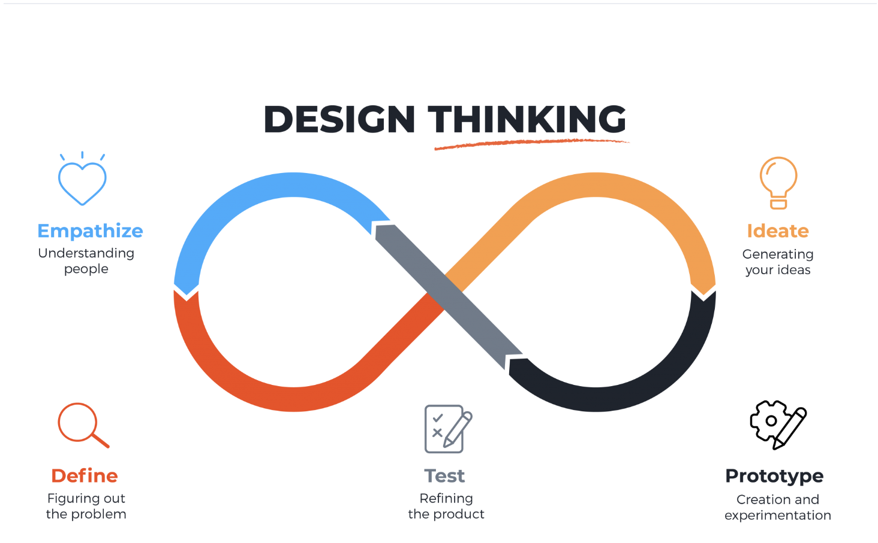
https://images.app.goo.gl/4v3hCrsnW16tNzLw6
Empathize. The researchers aim to develop a profound understanding of the end-users by engaging with the Sports Development Office (SDO) and analyzing their daily workflow. This involves conducting interviews with the SDO director and staff, observing how athlete information is currently being processed, and identifying the challenges in managing athlete records manually.
Through this process, the researchers discovered that the SDO manages the records of various sports using Microsoft Excel and printed attendance sheets. Each sport has its own file, and every month, the representatives summarize and submit these to the SDO for verification. This repetitive process consumes time and often leads to inconsistencies or missing data.
To better understand the root cause of these challenges, the 5 Whys analysis was applied. The result revealed that the main problem stemmed from the absence of a centralized and automated system that could store, organize, and visualize athlete data efficiently. The SDO staff also mentioned the need for a simpler way to track athlete requirements and monitor their completion status without manually scanning through multiple files.
The empathy stage provided a clear understanding of the frustrations and goals of the SDO staff — they desired a system that is simple, accurate, and efficient in managing records, eliminating the need for repeated encoding and manual computation. The insights gathered in this phase served as the foundation for the next stages of the design thinking process.
Figure 2
5-Why Analysis
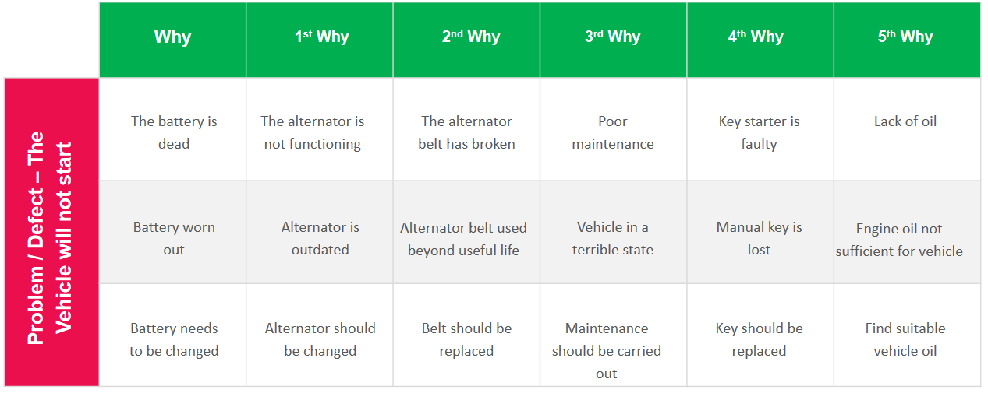
Define. This stage involves synthesizing the information gathered to articulate the challenges faced by the SDO. This step is essential in framing the design challenge accurately. The researchers analyzed and distilled the collected data, identifying patterns and themes that informed the creation of a concise problem statement.
Defining the challenge sets the direction for the next stages, ensuring that the design process focuses on addressing the most critical issues. After the empathy stage, the researchers identified the main concern of the Sports Development Office:
“How might we develop a centralized, efficient, and analytics-driven system that simplifies athlete information management and reduces manual workload?”
From this, the How Might We (HMW) statements were formulated to direct the design process:
- HMW 1: How might we develop a unified digital system for athlete data management?
- HMW 2: How might we integrate data analytics to provide actionable insights for the SDO?
- HMW 3: How might we create a user-friendly interface for both staff and athletes?
Ideate. The creative phase involves generating a diverse range of innovative ideas to tackle the identified problems. During this stage, the researchers brainstormed potential solutions that would meet the needs of the SDO staff and athletes.
Various ideas were explored, including:
- An attendance monitoring app that records training participation through scanning.
- An athlete recovery tracker for monitoring health and injury updates.
- A web-based athlete information management system (AIMS) that centralizes athlete records, automates report generation, and integrates analytics.
After evaluating the feasibility of each concept, the third idea was selected as the most viable. The proposed Athlete Information Management System (AIMS) focuses on the core problem: inefficient manual data management. It will serve as a centralized web-based platform where the SDO can store, update, and analyze athlete data with ease.
To ensure innovation, the system will incorporate data analytics, an emerging technology that visualizes athlete information in real-time. The analytics dashboard will display essential statistics such as the total number of registered athletes, gender distribution, and requirement completion rate.
The ideation process produced the following key features:
- SDO Dashboard for managing athlete profiles and generating reports.
- Athlete Portal for submitting personal and requirement details.
- Analytics Visualization for viewing data summaries and performance insights.
- User Access Control for maintaining system security.
Through ideation, the researchers established a creative and feasible concept that could significantly improve the SDO’s workflow and data management capabilities.
Prototype. In this stage, researchers transform the
selected ideas from the Ideation phase into tangible
representations. Prototypes can take various forms, from physical models to digital simulations, providing a
tangible and visual exploration of potential solutions. Creating prototypes allows designers to test concepts practically, enabling them to identify strengths,
weaknesses, and areas for improvement before committing to
a final design.
Then, in the next paragraph, include their specific activities and deliverables that you have done, and their descriptions.
Figure 2
Student Athlete General Profile View
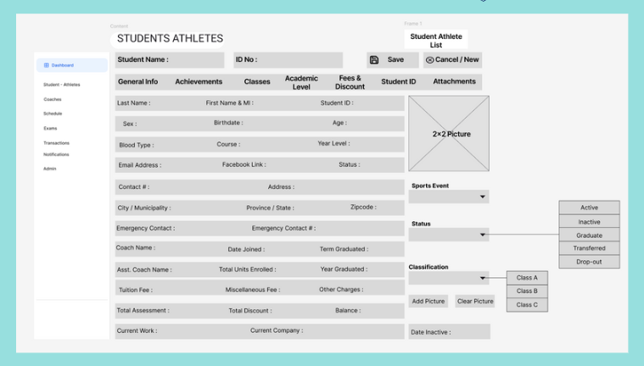
The Student Athlete Profile Management screen is the administrative access point for managing athlete details. This view, under the General Info tab, consolidates essential personal data (e.g., contact, emergency, and coaching details), thereby directly addressing data fragmentation by providing a single source of truth. It includes crucial fields for tracking the athlete's Status (Active, Inactive, Graduate, Transferred, Drop-out) and Classification. This interface provides the fundamental data structure necessary for the Dashboard to function, fulfilling the objective of identifying the features of the proposed system and enabling SDO staff to monitor athlete status
Figure 3
Achievements, Academic, Fees, Classes

This figure displays the structured tabular forms used under the respective profile tabs to input and track complex, non-personal data necessary for eligibility and reporting. The Achievements table allows SDO staff to record athletic success (Year, Sports Event, Awards), which is vital for generating achievement statistics. The Academic Evaluation and Classes tables capture data on units enrolled and passed, while Fees and Discounts consolidate financial data. The structured input across these tables is a prerequisite for accurate automated reports and provides the raw data foundation for the analytics dashboard.
Figure 4
Attachments and Document Verification

The Attachments table visualizes the system's functionality for managing required document submissions. This feature allows SDO staff to view details such as the document's Date, Name, Type, and File Type. This functionality is critical for fulfilling the objective to enable the SDO to verify documents and monitor athlete status, eliminating the persistent fear of missing a record and streamlining compliance tracking.
Test. Lorem ipsum dolor sits amet, consectetur adipiscing elit, sed do eiusmod tempor incididunt ut labore et dolore magna aliqua. Ut enim ad minim veniam, quis nostrud exercitation ullamco laboris nisi ut aliquip ex ea commodo consequat. Duis aute irure dolor in reprehenderit in voluptate velit esse cillum dolore eu fugiat nulla pariatur.
Then, in the next paragraph, include their specific activities and deliverables that you have done, and their descriptions.

REFERENCES
Gallardo, L., Garcia, F., & Martinez, R. (2024). Integrating multi-source data for holistic athlete management: A framework for data-driven coaching. International Journal of Sports Science & Coaching, 19(1), 45-58.
Johnson, P., & Lee, K. (2021). Breaking down silos: The impact of integrated data systems on organizational agility. Journal of Organizational Computing and Electronic Commerce, 31(2), 112-129.
Ogunlere, S., Adewumi, A., & Akinwunmi, A. (2020). Design and implementation of a web-based student athlete management information system. International Journal of Advanced Computer Science and Applications, 11(8), 540-548.
Smith, J., & Chen, H. (2022). The productivity paradox of manual data entry: A study of digital transformation in public sector agencies. Government Information Quarterly, 39(3), 101718.
Williams, R. (2023). Data quality in the wild: A systematic review of human-factor-induced errors in manual data systems. Data & Knowledge Engineering, 144, 102113.

APPENDICES
Appendix A
Communication Letter
Please take note that the Appendices are usually arranged according to the timeline or based on how they appear on the manuscript. Information that is usually placed in the manuscript include, but are not limited to:
Communication letter
Endorsement letter
Business model canvas
Initial literature review
Documentation of interviews and tests during the 5-why analysis and design thinking processes

Appendix B
Documentation

Appendix C
Sample A

